LAB TASK 08
ROLL NO : 24K-0954
Q1
INCLUDE Irvine32.inc

.data
nums SDWORD 5 DUP(?)
msg1 BYTE "Enter number ", 0
msg2 BYTE ": ", 0
posMsg BYTE "Positive numbers: ", 0
negMsg BYTE "Negative numbers: ", 0
zeroMsg BYTE "Zeros: ", 0
posCount DWORD 0
negCount DWORD 0
zeroCount DWORD 0

.code
main PROC
mov ecx, 5 ; loop counter
mov esi, OFFSET nums ; pointer to array
mov ebx, 1 ; number counter

input_loop:
mov edx, OFFSET msg1
call WriteString
mov eax, ebx
call WriteDec
mov edx, OFFSET msg2
call WriteString
call ReadInt
mov [esi], eax ; store input
add esi, 4
inc ebx
loop input_loop

; reset for processing
mov ecx, 5
mov esi, OFFSET nums

count_loop:
mov eax, [esi]
cmp eax, 0
jg positive
jl negative
je zeroVal

positive:
inc posCount
jmp next
negative:
inc negCount
jmp next
zeroVal:
inc zeroCount

next:
add esi, 4
loop count_loop

; display results
mov edx, OFFSET posMsg
call WriteString
mov eax, posCount
call WriteDec
call CrLf

mov edx, OFFSET negMsg
call WriteString
mov eax, negCount
call WriteDec
call CrLf

mov edx, OFFSET zeroMsg
call WriteString
mov eax, zeroCount
call WriteDec
call CrLf

exit
main ENDP
END main

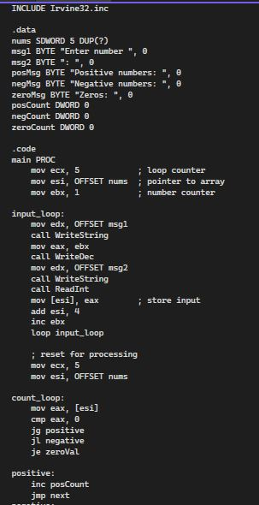
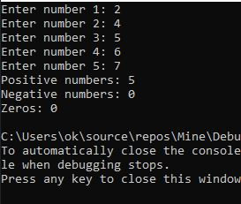

Q2

INCLUDE Irvine32.inc

.data
nums SDWORD 5 DUP(?)
msg BYTE "Enter 5 numbers:", 0
revMsg BYTE "Reversed order: ", 0

.code
main PROC
mov edx, OFFSET msg
call WriteString
call CrLf

mov ecx, 5
mov esi, OFFSET nums

input_loop:
call ReadInt
mov [esi], eax
add esi, 4
loop input_loop

mov edx, OFFSET revMsg
call WriteString

mov ecx, 5
mov esi, OFFSET nums
add esi, 16 ; point to last element (5*4 - 4 = 16)

reverse_loop:
mov eax, [esi]
call WriteInt
mov al, ' '
call WriteChar
sub esi, 4
loop reverse_loop

call CrLf
exit
main ENDP
END main

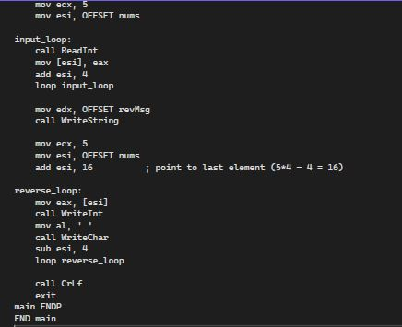
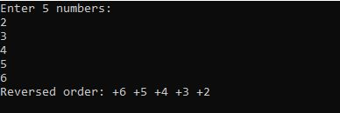
Q3

INCLUDE Irvine32.inc

.data
nums SDWORD 5 DUP(?)
msg BYTE "Enter numbers: ", 0
largestMsg BYTE "Largest number: ", 0
smallestMsg BYTE "Smallest number: ", 0

.code
main PROC
mov edx, OFFSET msg
call WriteString
call CrLf

mov ecx, 5
mov esi, OFFSET nums

input_loop:
call ReadInt
mov [esi], eax
add esi, 4
loop input_loop

; initialize
mov esi, OFFSET nums
mov eax, [esi]
mov ebx, eax ; ebx = largest
mov edx, eax ; edx = smallest
add esi, 4
mov ecx, 4

find_loop:
mov eax, [esi]
cmp eax, ebx
jg new_largest
cmp eax, edx
jl new_smallest
jmp cont

new_largest:
mov ebx, eax
jmp cont
new_smallest:
mov edx, eax

cont:
add esi, 4
loop find_loop

; display largest
mov edx, OFFSET largestMsg
call WriteString
mov eax, ebx
call WriteInt
call CrLf

; display smallest
mov eax, edx ; <-- WRONG in original. We must move smallest (in edx) to eax first,
; but edx currently holds smallest so do that BEFORE we overwrite edx.
; Correct sequence (do not overwrite smallest until saved):
; mov eax, edx
; mov edx, OFFSET smallestMsg
; call WriteString
; call WriteInt

; So we implement correctly below:

; (Restore correct values:)
mov eax, edx ; move smallest value into eax
mov edx, OFFSET smallestMsg
call WriteString
call WriteInt ; prints eax (smallest)
call CrLf

exit
main ENDP
END main
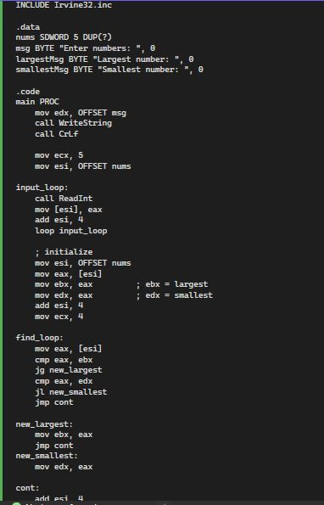
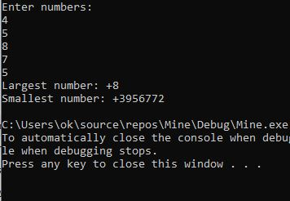

Q4

INCLUDE Irvine32.inc

.data
msg BYTE "Enter a word: ", 0
vowelMsg BYTE "Vowels: ", 0
consMsg BYTE "Consonants: ", 0
buffer BYTE 50 DUP(0)
vowelCount DWORD 0
consCount DWORD 0

.code
main PROC
mov edx, OFFSET msg
call WriteString
mov edx, OFFSET buffer
mov ecx, SIZEOF buffer
call ReadString

mov ecx, eax ; length of string
mov esi, OFFSET buffer

check_loop:
mov al, [esi]
cmp al, 0
je done
; check for vowel (lowercase)
cmp al, 'a'
je vowel
cmp al, 'e'
je vowel
cmp al, 'i'
je vowel
cmp al, 'o'
je vowel
cmp al, 'u'
je vowel
; check for uppercase
cmp al, 'A'
je vowel
cmp al, 'E'
je vowel
cmp al, 'I'
je vowel
cmp al, 'O'
je vowel
cmp al, 'U'
je vowel

; else consonant
inc consCount
jmp next

vowel:
inc vowelCount

next:
inc esi
loop check_loop

done:
mov edx, OFFSET vowelMsg
call WriteString
mov eax, vowelCount
call WriteDec
call CrLf

mov edx, OFFSET consMsg
call WriteString
mov eax, consCount
call WriteDec
call CrLf

exit
main ENDP
END main

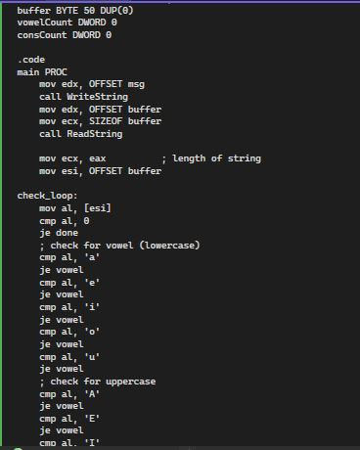
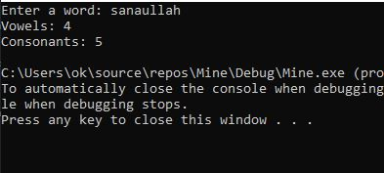

Q5
INCLUDE Irvine32.inc

.data
msg BYTE "Enter a number: ", 0
resMsg BYTE "Factorial: ", 0

.code
main PROC
mov edx, OFFSET msg
call WriteString
call ReadInt
mov ecx, eax ; counter = number
mov eax, 1 ; result = 1

fact_loop:
cmp ecx, 0
je done
mul ecx
loop fact_loop

done:
mov edx, OFFSET resMsg
call WriteString
call WriteDec
call CrLf
exit
main ENDP
END main

